

**Quick Start Tutorials: How to load an Agent**

We assume that you obtained a correctly compiled agent (following our tutorial 'how to compile an agent'). Now you can add the agent in one of the following two ways: using the GUI or editing the XML file.

## Load the agent using the GUI

An agent can be easily added by going to the “Agents” tab in the “Components Window” (Figure 1). Next, pressing right click opens a popup with the option to add a new agent. The final step is to select the main class of your agent[1].

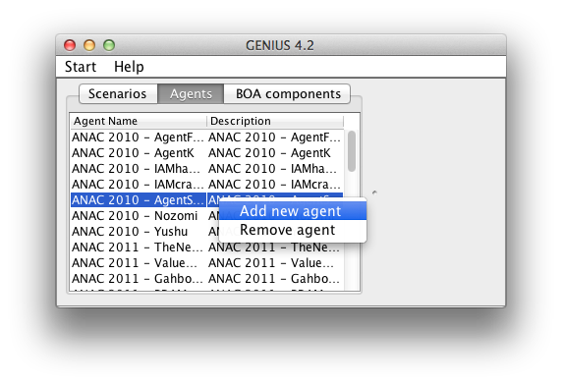

Figure . Adding an agent using the GUI.

## Loading the agent using XML

A compiled agent can also be loaded by directly adding the agent to the repository using the agentrepository.xml file. The code below visualizes a repository with a single agent. An agent element consists of several subelements; the first element is the description of the agent which is visualized in the GUI; the second element is the classPath specifying were the compiled agent class is located; the third element specifies the agentName; finally the optional element params specifies the parameters and their values available to the agent. In this case, a parameter “e” with value 2 and a parameter “time” with value 0.95 is specified. Variables can be accessed during the negotiation by using the getStrategyParameters method.

<?xml version="1.0" encoding="UTF-8" standalone="yes"?>

<repository fileName="agentrepository.xml">

<items >

<agentRepItems >

<agentRepItem

description="Other agents - SimpleAgent"

classPath="agents.SimpleAgent"

agentName="SimpleAgent"

params="e=2;time=0.95"/>

</agentRepItems >

</items>

<filename>agentrepository.xml</filename>

</repository >

1. The main class is the class that extends the Genius negotiator.Agent class.